Teacher Notes for “How do food molecules reach our muscles?
– Structure and Function of Organ Systems, Organs and Cells”

In this activity, students learn (1) how food is digested into smaller molecules and (2) how the digestive and circulatory systems cooperate to bring digested food molecules to muscles all over the body. Students analyze several examples of the relationship between structure and function in these organ systems. Finally, students use a claim, evidence, reasoning framework to evaluate the claim that structure is related to function in cells, organs and organ systems.

Two versions of the Student Handout are available – a more complete version (suitable for most high school students) and a simpler version (suitable for most middle school students). In these Teacher Notes, the question numbers are specified as question number in the more complete version of the Student Handout [question number in the simpler version].

Learning Goals
In accord with the Next Generation Science Standards:
- This activity helps students to prepare for the Performance Expectations:
- MS-LS1-3. "Use argument supported by evidence for how the body is a system of interacting subsystems composed of groups of cells."
- HS-LS1-2. "Develop and use a model to illustrate the hierarchical organization of interacting systems that provide specific functions within multicellular organisms."
- Students learn the following Disciplinary Core Idea (LS1.A) "In multicellular organisms, the body is a system of multiple interacting subsystems. These subsystems are groups of cells that work together to form tissues and organs that are specialized in particular body functions." "Multicellular organisms have a hierarchical structural organization, in which any one system is made up of numerous parts and is itself a component of the next level."
- Students engage in recommended Scientific Practices, including:
- "Constructing Explanations. Apply scientific ideas, principles, and/or evidence to provide an explanation of phenomena…".
- “Engaging in an Argument from Evidence. Construct… and present… a written argument… based on data and evidence.”
- This activity focuses on the Crosscutting Concept: Structure and function. "The functions and properties of natural and designed objects and systems can be inferred from their overall structure, the way their components are shaped and used, and the molecular substructures of its various materials."

Instructional Suggestions and Background Information
Your students should have a basic understanding of molecules and cells before beginning this activity. To introduce cell structure and function, I recommend the analysis and discussion activity, “Cells – How do they carry out the activities of life?” (https://serendipstudio.org/exchange/bioactivities/Cells).

If, before this activity, you want your students to review levels of organization, I recommend the analysis and discussion activity, “Levels of Organization in Biology” (https://serendipstudio.org/exchange/bioactivities/LevelsOrganization). For a brief review, you may want to use the figure below.

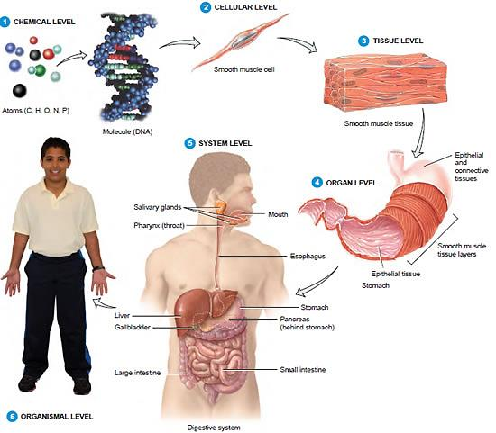
(http://www.protein-structure.net/images/Body-Systems.jpg)

To maximize student participation and learning, I suggest that you have your students work individually, in pairs, or in small groups to complete groups of related questions and then have a class discussion after each group of related questions. In each discussion, you can probe student thinking and help your students to develop a sound understanding of the concepts and information covered before moving on to the next group of related questions.

A key is available upon request to Ingrid Waldron (iwaldron@upenn.edu). The following paragraphs provide additional instructional suggestions and biological information – some for inclusion in your class discussions and some to provide you with relevant background that may be useful for your understanding and/or for responding to student questions.

The recommended 8.5-minute video, “The Digestive System” (https://www.youtube.com/watch?v=eSGRpPcJGlA) provides a clear, informative introduction to the digestive system. You may want to stop just before 8 minutes, right when the video shifts from describing the functions of the large intestine to a man describing the resources on their website. I recommend that you show this video twice, both before and after your students read questions 1-3 [1-3].

The two diagrams of the digestive system (on page 2 of both versions of the Student Handout) illustrate how different diagrams of the same thing convey somewhat different information and are useful for different purposes. The first diagram shows the sequence of the organs in the digestive system, whereas the second diagram shows the anatomical arrangement in our bodies. The liver and gallbladder are shown in both diagrams, but their function is not described. The liver secretes and the gallbladder stores bile; bile helps to emulsify lipids to facilitate their digestion and also helps to neutralize stomach acid as it enters the small intestine.

Chewing food in the mouth before it enters the small intestine has the advantage of breaking food into smaller particles which allows the multiple digestive enzymes in the small intestine to act on more of the food molecules (see the figure and explanation on the bottom of page 1 of both versions of the Student Handout). Advantages of having food pass through the stomach before the small intestine include:
- The storage capacity of the stomach allows a person to eat large meals and gradually release small amounts of partially digested food to the small intestine. If too much food enters the small intestine too rapidly, the small intestine malfunctions and cannot digest all the food. People who have reduced stomach volume (due to surgery for cancer or weight loss) must eat small meals throughout the day. Otherwise, they tend to develop symptoms such as nausea and cramping (https://www.uhbristol.nhs.uk/media/1293981/greenpostopbooklet.pdf).
- The stomach acid kills disease-causing microorganisms before they enter the small intestine with its large surface area, blood supply, and potential for infection.

The small intestine is very long – about 3-5 m (10-16 feet). The length of the small intestine, the folds in the epithelium that lines the small intestine, the villi and the microvilli all increase the surface area for absorption. This surface area is approximately 30 m² (320 ft.² = an area that would be 16 x 20 feet if it were all spread out)! The narrow diameter of the small intestine (~2.5 cm) ensures that digested food molecules in the lumen are relatively near to the wall of the small
intestine where they can be absorbed. (A lumen is the cavity or space within a biological organ or other structure.)

The cells in the epithelium that lines the lumen of the small intestine synthesize protein enzymes that complete the digestion of food molecules (https://www.youtube.com/watch?v=dERCrrzNRL8). These cells also pump in sugars and amino acids, which increases absorption of these useful molecules from the lumen of the small intestine (https://uen.pressbooks.pub/anatomyphysiology2/chapter/small-intestine/). To accomplish these functions, these cells need lots of cytoplasm with lots of mitochondria, ribosomes in rough endoplasmic reticulum, and Golgi apparatus. These metabolically active cells need lots of mitochondria to make ATP to provide the energy for the synthesis and transport of the molecular pumps and enzymes, as well as the function of the molecular pumps. Rough endoplasmic reticulum and Golgi apparatus are needed because:
- the digestive enzymes and pump proteins are embedded in the part of the cell membrane that faces the lumen of the small intestine and
- the rough endoplasmic reticulum and Golgi apparatus process proteins that are embedded in the cell membrane.
These metabolically active epithelial cells are tall and have much more cytoplasm per epithelial area than the relatively inactive thin, flat cells in capillary walls.

The capillary wall cells do not synthesize enzymes or pump useful molecules; instead, the thin, flat shape provides a minimum barrier to diffusion. In the small intestine, digested food molecules diffuse across a capillary wall into the blood; near muscles and elsewhere in the body, digested food molecules diffuse from the blood to the surrounding cells. Diffusion is reasonably rapid over very short distances, but very slow over any substantial distance. Thus, the single layer of thin, flat cells in the wall of capillaries maximizes diffusion into and out of the blood. The relationship between structure and function is illustrated by the contrast between the thin metabolically inactive cells that form the capillary wall and the tall metabolically active cells in the epithelium that lines the lumen of the small intestine.

The circulatory system is also called the cardiovascular system. Question 9 [8] illustrates the
important general principle that our bodies consist of multiple organ systems that cooperate to accomplish important functions. For example, the digestive and circulatory systems cooperate to provide cells all over the body with digested food molecules that can be used for cellular respiration or as building blocks to synthesize needed molecules.  You may want to include additional examples such as the cooperation between the respiratory system and the circulatory system to provide oxygen to every cell in the body and also to remove the waste product, carbon dioxide. This highly simplified diagram illustrates how the circulatory system is crucial for allowing the specialized digestive, respiratory, and excretory systems to serve needed functions for all the cells in the body. | 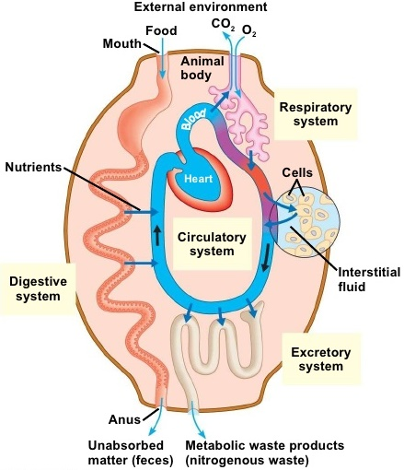

Question 10 [9] provides the opportunity to review the Disciplinary Core Idea, “Multicellular organisms have a hierarchical structural organization, in which any one system is made up of numerous parts and is itself a component of the next level.”

Question 11 [10] guides students in developing a scientific argument through the “Claim, Evidence, Reasoning” or “CER” approach. If your students are not familiar with this approach, you may want to introduce them to the idea that, in a scientific argument, a claim is evaluated on the basis of the available evidence, with reasoning to explain how the evidence is relevant to the claim. Criteria for evaluating the validity of a scientific argument include:
- how well the claim fits with all the available evidence,
- the relevance of the evidence (as explained in the reasoning),
- the quality of the evidence, and
- whether there is enough evidence.
Natural selection results in the observed relationships between structure and function. However, constraints on evolution often prevent optimal structural solutions to functional challenges.

Additional information about the digestive system is available at:
- https://www.webmd.com/digestive-disorders/your-digestive-system
- https://www.innerbody.com/image/digeov.html

Additional information for teaching about scientific argumentation is available at:
- http://www.scientificargumentation.com/overview-of-scientific-argumentation.html
- The summer, 2013, issue of the Science Teacher (pages 30-55) has multiple articles that suggest various ways to develop students’ skills in scientific argumentation.
- https://undsci.berkeley.edu/understanding-science-101/how-science-works/the-logic-of-scientific-arguments/ takes a somewhat different approach to the components of a scientific argument.

Sources for Figures in Student Handout
- Surface area related to particle size – modified from https://www.nagwa.com/en/explainers/940192346175/
- Digestive system – modified from https://courses.lumenlearning.com/suny-ap2/chapter/chemical-digestion-and-absorption-a-closer-look/
- Small intestine – modified from https://www.sciencelearn.org.nz/images/2259-villi-in-the-small-intestine
- Capillary – modified from https://my.clevelandclinic.org/-/scassets/images/org/health/articles/21788-continuous-capillary-illustration
- Circulatory System – modified from https://www.uc.edu/content/dam/uc/ce/docs/OLLI/Page%20Content/OLLI%20Circulatory_System.pdf

Related Activities
How do muscles get the energy they need for athletic activity?
https://serendipstudio.org/exchange/bioactivities/energyathlete
In this analysis and discussion activity, students learn how muscle cells produce ATP by aerobic cellular respiration, anaerobic fermentation, and hydrolysis of creatine phosphate. They analyze the varying contributions of these three processes to ATP production during athletic activities of varying intensity and duration. Students learn how multiple body systems work together to supply the oxygen and glucose needed for aerobic cellular respiration. Finally, students use what they have learned to analyze how athletic performance is improved by the body changes that result from regular aerobic exercise.

By Ingrid Waldron, Biology Department, University of Pennsylvania, © 2025. These Teacher Notes and both versions of the Student Handout are available at https://serendipstudio.org/exchange/bioactivities/SFCellOrgan.
Quotations are from https://www.nextgenscience.org/ and https://www.nextgenscience.org/sites/default/files/HS%20LS%20topics%20combined%206.13.13.pdf.
Sugars and amino acids diffuse into the blood that flows through the capillaries inside each villus and fatty acids diffuse into lymph in the lacteals. The lymph is returned to the blood in the subclavian veins. The hepatic portal vein carries blood from the small intestine to the liver, which processes some of the food molecules that have been absorbed from the lumen of the small intestine. For example, after a meal, glucose levels are high in the blood that flows through the hepatic portal vein. The liver removes some glucose from the blood and converts it to a storage form (glycogen). Later, glycogen can be broken down to glucose for use between meals. From the liver, the blood flows to the heart which pumps blood containing nutrients to capillaries in the lungs and then near every cell in the body. Hormones play an important role in coordinating the functions of different parts of the digestive system. The nervous system controls the activity of the tongue and jaw muscles in the mouth and regulates other aspects of digestion.
The same considerations explain why the alveoli in the lungs are lined by a single layer of flattened cells.
These criteria are paraphrased from Argument-Driven Inquiry in Biology (by Sampson et al., NSTA Press). This book presents a useful, more extensive approach for developing students’ ability to engage in scientific argument.

